MSIM 441/541 & ECE 406/506
Computer Graphics & Visualization

Programming Assignment Three
Texture Mapping and Imaging Pipeline
Assigned November 17, Due 12:00 PM December 14

1. Overview
Texture mapping is one of the most important techniques used by modern computer graphics to render details with only moderate increase of computational complexity. In addition to the geometric graphics pipeline we have covered so far, OpenGL has an Imaging Pipeline that deals with pixel-storage modes, pixel-transfer operations, and pixel-mapping operations. With the development and advances in programmable graphics pipeline (e.g., vertex shaders and pixels shaders) in the past decade, texture mapping and imaging pipeline operations are becoming more important and frequently used for creating highly realistic 3D graphics. In this programming assignment, you will continue to develop the transportation simulation (Figure 1) you have started in Programming Assignment Two. You will customize an OBJ model by modifying its textures, create billboards with simple geometry and texture mapping, and take snapshots of the scene using the imaging pipeline. You will also have the option of optimizing your code architecture by adopting a simple simulation engine.

You will use your completed Programming Assignment Two as your base code. The instructor also developed additional new code to be used for this programming assignment.
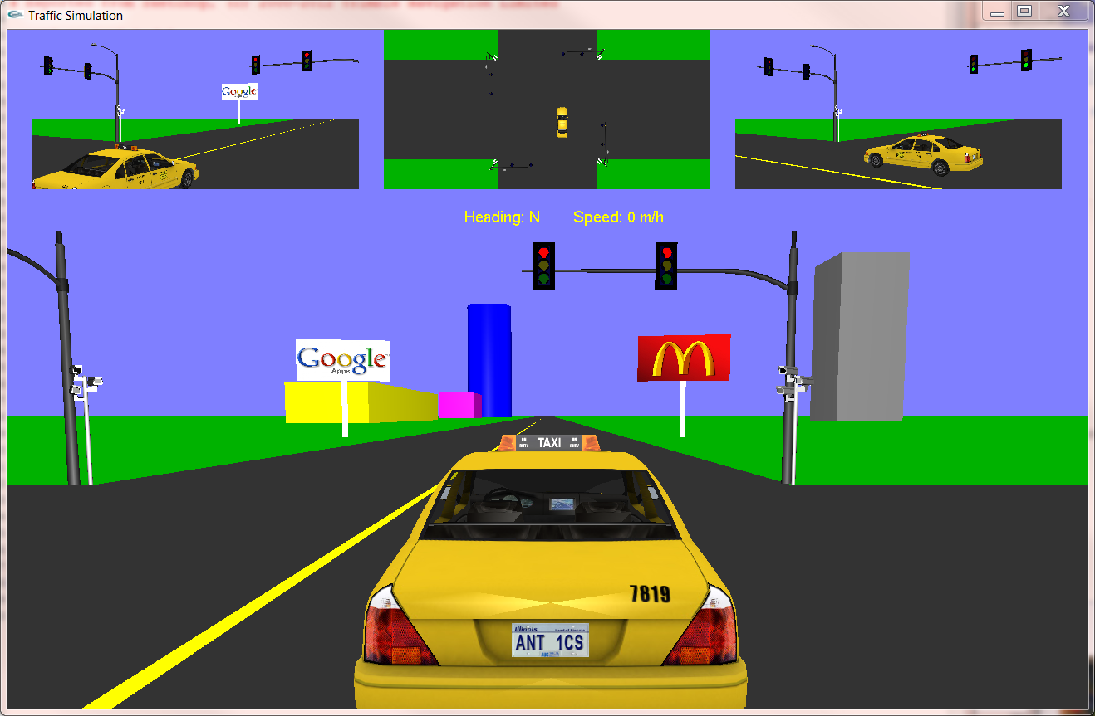
Figure 1. Transportation Simulation

2. Objectives
Objectives of this assignment are divided into two categories: 1) Review and Enhancement; and 2) Learning Outcomes. Review and Enhancement include knowledge and skills that you are supposed to have already before taking this course and give you an opportunity to enhance them. Learning Outcomes contain the new knowledge and skills you are expected to learn from this assignment.

2.1 Review and Enhancement
- File input/output (I/O)
- String operations using stringstream class
- Dynamic memory allocation and de-allocation
- Structures and classes in C++.
- Class inheritance and virtual methods
- Classes and algorithms provided by the C++ Standard Template Library (STL) (in particular, vector and map)
- Program debugging techniques

2.2 Learning Outcomes
- Understand the OBJ file format including both .obj and .mtl files.
- Understand different image formats, in particular, the PPM image format.
- Modify .mtl files to change texture images.
- Procedural generation of simple geometry in OpenGL.
- Perform basic image processing tasks with common software, such as Photoshop and Gimp.
- Understand image formatting and storage in OpenGL.
- Program basic image processing tasks in software.
- Create, use, and delete texture objects and understand the functions and parameters involved.
- Understand and use imaging pipeline to create snapshots (or screen captures) in OpenGL.
- Understand the OpenGL state machine.
- Understanding and use of at least the following OpenGL related concepts.
  - glGenTextures()
  - glDeleteTextures()
  - glBindTexture()
  - glTexImage2D()
  - glTexParameteri()
  - glTexEnvf()
  - glEnable()
  - glDisable()
  - glReadPixels()
  - glutSolidCube()
  - gluCylinder()

3. Tasks
3.0 New Code
Copy the following files from Blackboard to the project you developed in Programming Assignment Two.
- Billboard.h
- Billboard.cpp
- ObjModel.h
- ObjModel.cpp
- PPMImage.h
- PPMImage.cpp
3.1 A Customized Car
First you need to replace the car you used in Programming Assignment Two with the file taxi.obj. The OBJ parser provided by the instructor only supports texture files in the PPM format. However, the textures used by the file taxi.obj are in JPG (or JPEG) format. To continue using the OBJ parser provided by the instructor, you need to convert the JPG image files into PPM format. You can use the free, open source image editing software GIMP 2 for the format conversion. Also note that JPG files store the pixels by starting from the bottom-left corner of the image and then proceeding in a row major form, while PPM files start from the top-left corner and then proceed in a row major form. Thus, you need to do a vertical flip (in GIMP 2) when converting JPG to PPM. You also need to change the texture file names in the .mtl file to reflect the changes.

You also need to change the license plate in the taxi with the following text: “YourFirstName, MSIM xxx”, where YourFirstName is your first name and xxx is the course number in which you are enrolled. Carefully determine the font type, size, and layout of the text, as its aesthetics will be graded. You can also include a background (image) in the license plate.

3.2 Billboards
You will generate several billboards (at least two for MSIM 441/ECE 406 and four for MSIM 541/ECE 506) from scratch. In other words, you need to generate both the geometry and texture mapping in OpenGL by yourself and you cannot use OBJ files directly for the billboards. A partially developed class (by the instructor) Billboard is provided and you need to complete this class or develop your own class for the billboards. A (simple) billboard contains two parts: a board and a pillar. You can use simple geometry (e.g., rectangles) for both the board and pillar, and you need to apply texture mapping to the board to display the billboard image. The Billboard class must be general enough to model billboards of different size, elevation, and images.

The OBJ parser developed by the instructor has texture mapping capabilities. Read the code of the ObjModel carefully and understand the parts related to texture mapping. Obtain suitable images (e.g., human, animals, and commerce) and generate texture mapping for the billboards. Answer the following questions.
- What is the purpose of the OpenGL command glBindTexture()? Why do we need to use this command?
- What is the difference between the parameters GL_REPEAT and GL_CLAMP in the OpenGL command glTexParameteri()?
- Why do you need to use glEnable(GL_TEXTURE_2D) and glDiable(GL_TEXTURE_2D) in different places in your code?

Extra credits: Live Billboards (Exact Points Dependent on Complexity)
The billboards you generated so far are static, i.e., their images do not change with time. Live billboards display different images at different times (and even better, there are possible transitions between images, such as those transitions in Power Point presentations). The instructor provides a base project that contains a rotating cube with automatically updated, blended textures. You can build your live billboards utilizing the techniques in this base project.
3.3 Snapshots
You need to generate a snapshot of your OpenGL window when the ‘s’ key is pressed. The snapshot will be saved in the PPM format. You can use the same file name for the snapshot when the ‘s’ key is pressed multiple times (i.e., old snapshots will be overwritten). The PPMImage class declared a method VerticalFip() for flipping the image vertically. You need to implement this method. Answer the following questions.
- Why is a vertical flip needed before saving the snapshot?
- You need to call the function PPM::AllocateMemory() before calling PPM::WriteFile(). Explain why.
- Explain what the destructor of PPMImage does. Why is there a pair of square brackets?
- What are the two types supported by PPM images? Compare the two types (e.g., differences, advantages, disadvantages). How are the two types handled differently in PPM::WriteFile()?

Extra credits: Automatic Snapshots of Traffic Violation (5 Points)
When the car enters the intersection against a red signal, the surveillance cameras need to take snapshots automatically. For this task, you only need to implement automatic snapshot for the camera at the south-east corner and when the car is driving northbound. Several snapshots are needed for each red light violation. You need to name the snapshot files automatically, including date and time in the file names.

3.4 Simulation Engine (Extra Credit: 10 points)
At this point, you probably find your code is becoming messy since object oriented programming has not been fully utilized in this simulation. A better approach is to develop a simulation engine that encapsulates your simulation for easy reuse, revision, and enhancement in the future. The instructor has developed a simple simulation engine for the Sierpinski Gasket project. You need to adopt this simulation engine for this project by modifying the simulation engine accordingly for transportation simulation.

4. Coding (60 points)
Exercise good coding practices, such as naming variables meaningfully and properly, including comments of key classes, variables, functions, and code segments, and using indentations and proper spacing between tokens (e.g., variables, operators). Points will be deducted for lack of comments or bad formatting (e.g., no indentation or large blank spaces in the code). The following is the grade allocation for different tasks or functionalities of your program.
- Customized car: 10 points
- Generating billboards: 30 points
- Snapshots: 15 points
- Interactivity: 5 points

5. Report (40 points)
The report should contain at least the following sections and use the same formatting in this assignment description or other professional formats. Points will be deducted for improper formatting.
- Audience: The reader of your report is a software engineer who will continue your project because you have been just promoted to a higher-level position in your company. The software engineer didn’t know anything about your project previously.
- Introduction (5 points): overview of the assignment, such as background, objectives, and brief summary of what you have done for this assignment. Don’t repeat the assignment description verbatim.
- Program Design (15 points)
You will use doxygen to generate the documentation (help) file for your code. You need to generate documentation for all classes, class variables, class methods, and internal implementations of critical methods, for all types of access modifiers (public, protected, and private). Your documentation should include source code, class diagrams, call graphs, and caller graphs. Your documentation should be contained in a single .chm file.
- Results (15 points): Describe what you have done for each task specified in Section 3: Tasks. Include results and necessary screen captures for each task. Answer the questions in the task if any. Include one or more video captures.
- Conclusion and Discussion (5 points): Discuss your accomplishments, learning outcomes, and difficulties and how you can do better for this assignment.

6. Deliverables
Submit your report and your entire Visual Studio solution with the data files you used. Compress everything into one file and submit that file.

